**DJANGO**

**Step #1**

* Download Django installation
* Follow the instructions and procedure for installation
* These includes:
  + Summary for Windows
  + - Installed Python
  + - Verified or installed pip
  + - Created and activated a virtual environment
  + - Installed Django
  + - Created and ran your first Django project

**Step #2**

* Proceed to this link : <https://tutorial.djangogirls.org/en/how_the_internet_works/>

( Give you instructional Idea in how to use Django and the needed things enable to perform Django)

**Step #3**

* It introduce in how to use command line

These are the possible commands to use :

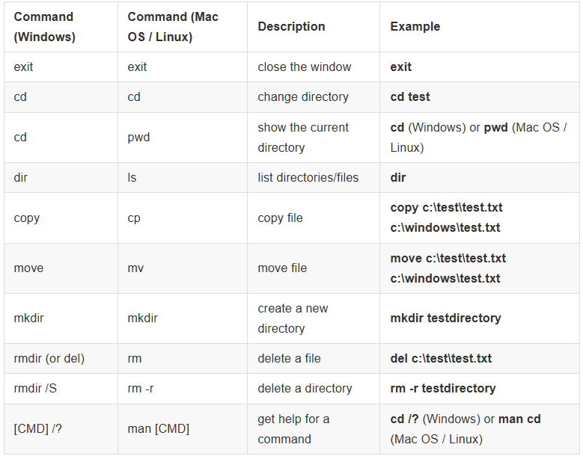

**Step #4**

* It introduces here and explains about Python
  + Simple and Easy to Learn
  + Versatile & Multipurpose
  + Massive Library Support
  + Large Community + Tons of Resources
  + In-Demand in Jobs
  + Cross-Platform
  + Great for Rapid Prototyping
  + Popular with Big Companies

**Step #5**

* Choose the possible Code Editor
* In my end, I am using Visual Studio Code :

Visual Studio Code is a source code editor developed by Microsoft for Windows, Linux and macOS. It includes support for debugging, embedded Git control, syntax highlighting, intelligent code completion, snippets, and code refactoring.

**Step #6**

* Introduction to Python includes the possible codes to use.

**Step #7**

* Introduce the Django and how it works
  + Installation